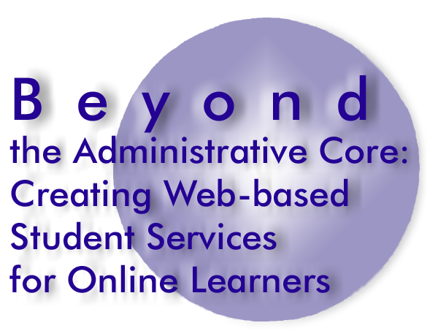

Technical Options Matrix

Enter the scenario numbers from your scenario forms in the first column. Then answer whether
the scenario is do-able, indicate if your institution already owns the software to create the
scenario activities – if not, decide whether your institution should build, buy or partner to
create the software, and estimate the development time and cost. Costs for staff time can be
calculated according to your budgeting requirements – negligible because salaries cover
the staff time or calculated at an hourly rate.

This kind of form could be used to record the decisions made at a group meeting or put
online and submitted by various individual respondents.

Use this information in the project plan to refine the schedule, resources and time factors.

Scenario  # | Do-able? | Own the  software? | If no, choose one option:  Build Buy Partner | Development  time in hours | Estimated  cost

