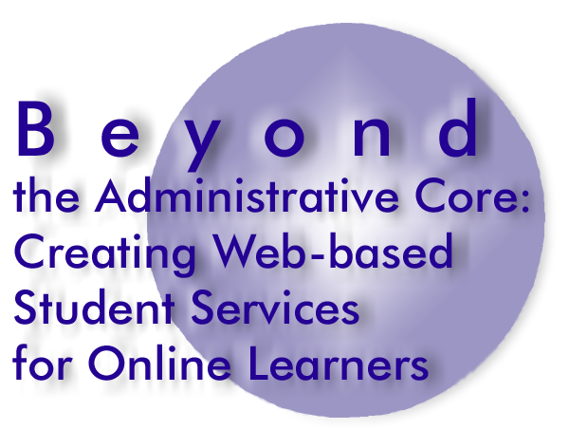

Software Inventory

Enter the name of the software package(s) used to support each service and its general function.

Student Service | Software Package | Software Functions

Administrative Core
Admissions
Registration
Financial Aid
Student Accounts
Course/Program Catalog & Schedule of Classes

Communications Suite
Student to Student
Faculty to Student
Faculty & Staff to Faculty & Staff
University to Student

Academic Suite
Academic Advising
Academic Counseling
Assessment and Testing (Diagnostic, Placement, & Academic)
Bookstore
Library
Remediation Services
Retention Services
Technical Support
Tutoring (Individual & Group)
Disabled Student Services

Personal Services Suite
Counseling (Personal)
Career Counseling & Placement Services
Ethical & Legal Services
Financial Planning (Budgeting, Banking, Loan & Credit Card Management)
Health Services
Orientation

Student Communities Suite
Student Activities (Recreation, Leadership, Academics, Religion & Spirituality)
Student Population Segments Services (International, Minority, Veteran, Alumni, etc)

